Abstract-- This project demonstrates the implementation of a Smart Home Automation System using Cisco Packet Tracer. This system integrates IoT devices to automate home functionalities, en efficiency, security, and convenience. The project explores IoT networking, device integration, and real-time monitoring, emphasizing the future potential of smart automation in residential environments
Smart Home Automation System
using Cisco Packet Tracer
Hamid Ali Instructor: Prof. Irfan Younas Mughal
BE Computer System Engineering
Sukkur IBA University
Sukkur, Sindh

Keywords: IoT, Cisco Packet Tracer, Smart Home Automation

INTRODUCTION
In today's fast changing tech world, systems for smart home automation have turned into a key part of living now. These setups mix Internet of Things (IoT) tech to manage and control home gadgets from afar, making things easier, saving energy, and boosting safety. As interest in smart living spaces grows, the chance to model and design these systems gives important views on what IoT-driven automation can do and its problems.
This project is about creating and setting up a Smart Home Automation System using Cisco Packet Tracer. The system includes IoT devices like smart lights, motion detectors, thermostats, and security cams, all linked through one central IoT controller. The goal is to simulate a working smart home where devices work together smoothly to improve life quality.

Methodology
The development of the Smart Home Automation System in Cisco Packet Tracer involved several structured steps to ensure an efficient and functional design:
- Designing the Network Architecture:
  - A wireless network was designed to connect smart devices using an IoT-enabled router.
  - The setup included a central IoT controller, wireless access points, and various interconnected IoT components.
- Selecting and Arranging Devices:
  - IoT-compatible devices such as smart lights, motion detectors, temperature regulators, security cameras, and automated door locks were incorporated.
  - These devices were arranged within a simulated home environment in Packet Tracer.
- Configuring Devices:
  - Each IoT device was linked to the central controller and configured with specific settings, such as network credentials and operational parameters (e.g., light activation on motion or temperature thresholds for climate control).
- Creating Automation Rules:
  - Logical rules were programmed to enable device interactivity. For example:
    - Motion-triggered lights activation.
    - Automated thermostat adjustments based on room temperature.
    - Security alerts when unauthorized access was detected.
- Building a Monitoring Dashboard:
  - A centralized dashboard was created to oversee the status of all devices.
  - The interface enabled users to monitor devices in real time and perform manual overrides when necessary.
- Testing and Simulation:
  - The setup was evaluated through various scenarios to ensure that the devices responded correctly to both automation rules and user inputs.
  - Simulations included tests for security, energy efficiency, and device synchronization.
- Optimizing Performance:
  - Issues such as network latency and device response delays were identified and resolved to enhance system performance.

Implementations
The implementation of the Smart Home Automation System in Cisco Packet Tracer was carried out step by step to ensure seamless functionality and integration of all components. Below is a detailed explanation of the process:
- Setting Up the IoT Network:
  - A Wi-Fi-enabled IoT router was placed as the central hub to connect all smart devices.
  - Wireless access points were added to extend the range and ensure stable connectivity for all devices within the virtual home.
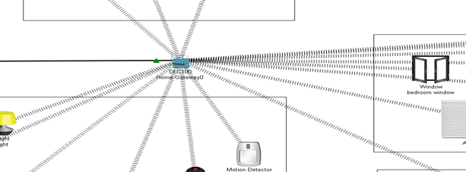
- Adding Smart Devices:
  - Essential smart devices such as lights, cameras, motion sensors, thermostats, and door locks were selected from the Packet Tracer IoT library.
  - Each device was positioned within specific rooms in the simulated home layout to match real-world usage scenarios.
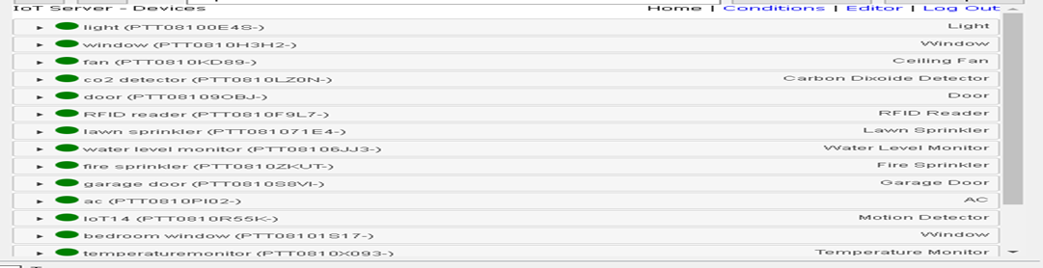
- Connecting Devices to the IoT Router:
  - All smart devices were connected wirelessly to the IoT router.
  - Device configurations included assigning unique IP addresses and integrating them with the central IoT controller for centralized management.
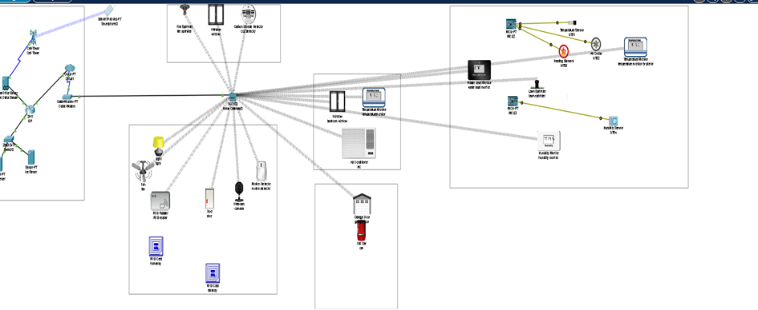
- Programming Automation Logic:
  - Automation rules were written to create interconnections between devices, ensuring intelligent responses to specific events. For example:
    - Lights automatically turned on or off when motion sensors detected activity.
    - The thermostat adjusted the temperature if it exceeded or fell below predefined thresholds.
    - Security cameras activated and recorded footage when the door sensor detected unauthorized access.
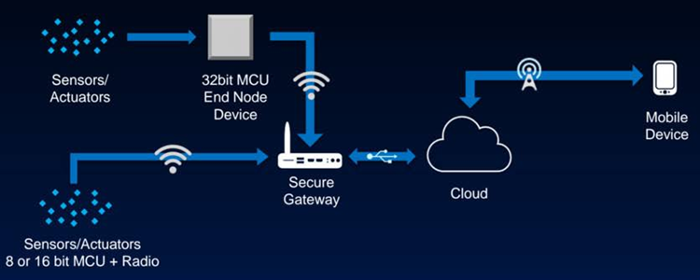
- Creating a Centralized Control Dashboard:
  - A user interface was configured within Packet Tracer to monitor device statuses and control their functions remotely.
  - The dashboard provided live updates on each device and allowed users to override automation settings when required.
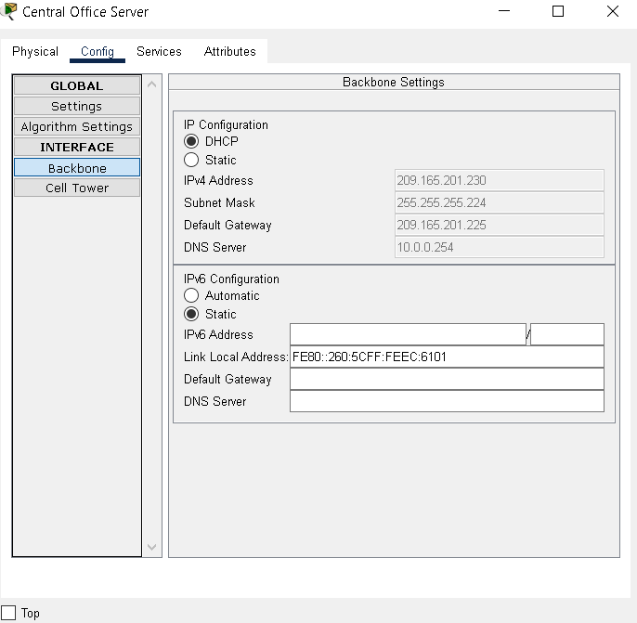

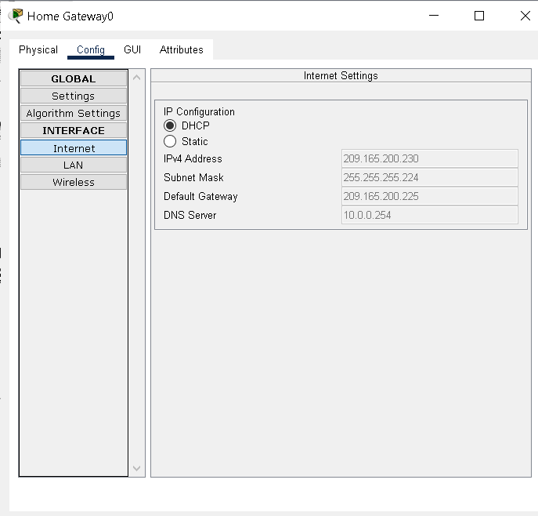

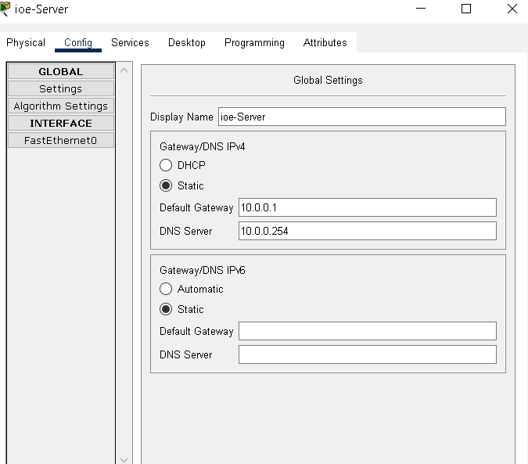
SL NO | Device | Function
1. | Central office server | Used for connecting cellular system to the router.
2. | Router | Used to interconnect home with cellular network.
3. | Cable modem | Used for connecting home with internet
4. | IOT server | To control registered smart IOT device
5. | End devices | Connect to home gateway to access smart objects
6. | Home gateway | Used for registering and providing ip address for iot devices
7. | Fan | Used for ventilation
8. | Web cam | Records the environment
9. | Light | Provide light
10. | Motion detector | Detects a motion
11. | Smart door | Connect to home gateway and provides function based event
12. | Cell tower | Provide coverage for user to control home appliances from remote area
13. | Co2 detector | Detects level of co2 in the kitchen
14. | Water level monitor | Used for detection of water level
15. | Lawn sprinkler | Used to sprinkle water
16. | Temperature sensor | Used for sensing the temperature
17. | Old car | Used to simulate different scenario in home design since it affect, co, co2 and smoke level
18. | Air conditioner | Used to cool the room
19. | Smart window | Controlling the window remotely
20. | Humidifier | Controls humidity in the atmosphere
21. | RFID reader | Read the ID of an RFID card
22. | RFID card | Interacts with the RFID reader

- Simulating Real-World Scenarios:
  - Various scenarios, such as a nighttime security check and energy-saving mode activation, were simulated to test system efficiency.
  - Manual and automated operations were analyzed to ensure proper synchronization between devices.
- Optimizing the System:
  - Network configurations were fine-tuned to address any connectivity or response delays.
  - Redundant automation rules were simplified to reduce processing overhead, ensuring smooth operation.
- List of components used for implementation
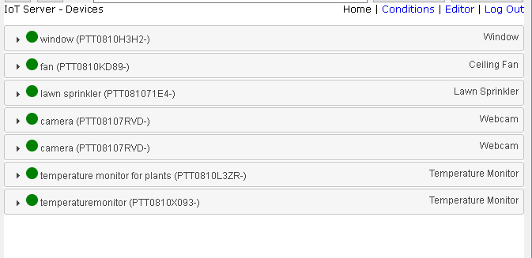
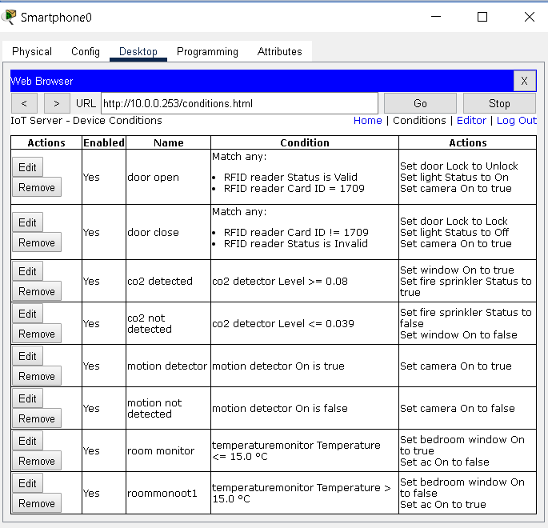

Results
The Smart Home Automation System worked effectively, with devices responding accurately to automation rules like motion-triggered lights and temperature adjustments. The centralized dashboard allowed real-time control and monitoring, making the system user-friendly. Simulations confirmed improved convenience, security, and energy efficiency, highlighting the system's practicality and reliability.
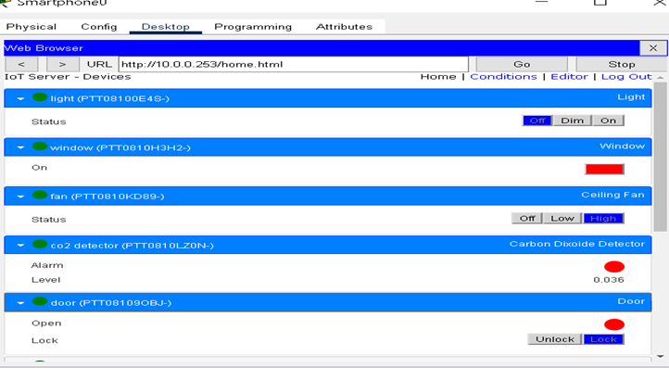

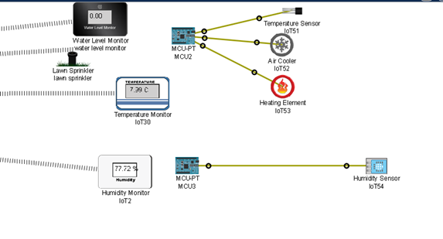

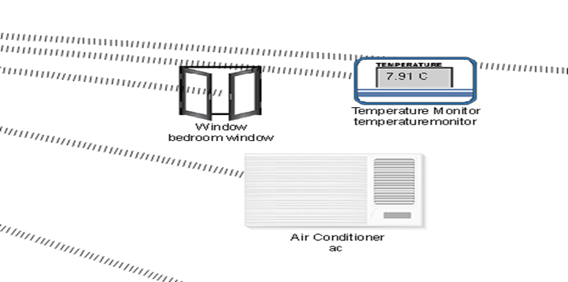

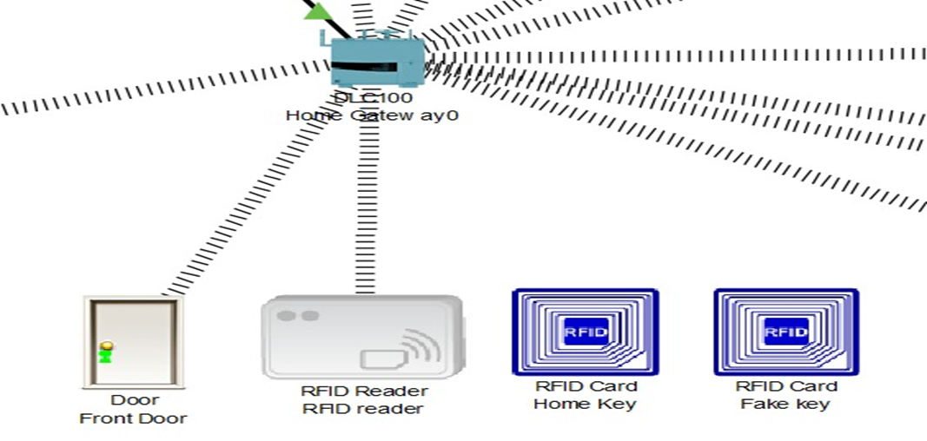

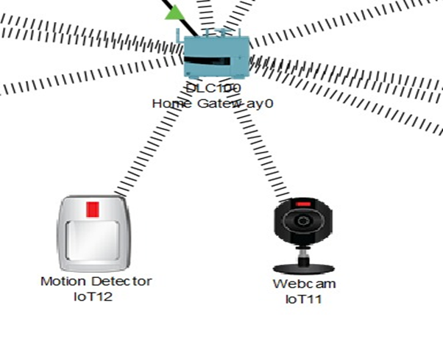

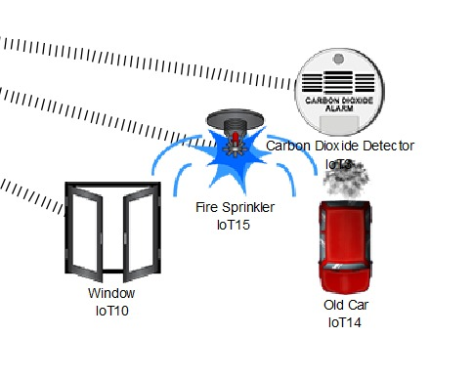

Conclusion
The Smart Home Automation System project showcased how IoT technology can revolutionize home living by creating an intelligent, automated environment. Through the integration of devices like smart lights, motion sensors, and thermostats, the system improved convenience, safety, and energy management. Using Cisco Packet Tracer, the simulation successfully illustrated how all components functioned seamlessly, with automation rules working as intended. This project highlights how IoT can enhance home efficiency, security, and sustainability, offering a foundation for future improvements in smart home technology.

References.
www.youtube.com/@gurutechnetworks
This channel helps me a lot to build this Smart home automation system.

https://www.ijraset.com/research-paper/iot-based-a-smart-home-automation-system-using-packet-tracer
This also help me to understand the logics between devices and routers connectivity.

 

